GAEA AND ARES IN GREEK MYTHOLOGY:
A CHANCE TO CREATE!
BY MYTAKI DIMITRA,TEACHER OF GREEK LANGUAGE AND LITERATURE

NAME OF THE GROUP:………………………………………………………………………………………

WATCH THE VIDEO-BOOK OF THE FOLLOWING TEXT AND THEN READ IT ON PAPER.

FIRST TEXT: ORIGIN OF THE WORLD-FIRST DYNASTY-
URANUS AND GÆA
The ancient Greeks had several different theories with regard to the origin of the world, but the generally accepted notion was that before this world came into existence, there was in its place a confused mass of shapeless elements called Chaos. These elements becoming at length consolidated (by what means does not appear), resolved themselves into two widely different substances, the lighter portion of which, soaring on high, formed the sky or firmament, and constituted itself into a vast, overarching vault, which protected the firm and solid mass beneath.
Thus came into being the two first great primeval deities of the Greeks, Uranus and Ge or Gæa. Uranus, the more refined deity, represented the light and air of heaven, possessing the distinguishing qualities of light, heat, purity, and omnipresence, whilst Gæa, the firm, flat, life-sustaining earth, was worshipped as the great all-nourishing mother.[….] The first-born child of Uranus and Gæa was Oceanus, the ocean stream, that vast expanse of ever-flowing water which encircled the earth.[….]
But Uranus, the heaven, the embodiment of light, heat, and the breath of life, produced offspring who were of a much less material nature than his son Oceanus. These other children of his were supposed to occupy the intermediate space which divided him from Gæa. Nearest to Uranus, and just beneath him, came Aether (Ether), a bright creation representing that highly rarified atmosphere which immortals alone could breathe. Then followed Aër (Air), which was in close proximity to Gæa, and represented, as its name implies, the grosser atmosphere surrounding the earth which mortals could freely breathe, and without which they would perish. Aether and Aër were separated from each other by divinities called Nephelae. These were their restless and wandering sisters, who existed in the form of clouds, ever floating between Aether and Aër. Gæa also produced the mountains, and Pontus (the sea). She united herself with the latter, and their offspring were the sea-deities Nereus, Thaumas, Phorcys, Ceto, and Eurybia.
Co-existent with Uranus and Gæa were two mighty powers who were also the offspring of Chaos. These were Erebus (Darkness) and Nyx (Night), who formed a striking contrast to the cheerful light of heaven and the bright smiles of earth. Erebus reigned in that mysterious world below where no ray of sunshine, no gleam of daylight, nor vestige of health-giving terrestrial life ever appeared. Nyx, the sister of Erebus, represented Night, and was worshipped by the ancients with the greatest solemnity.
Uranus was also supposed to have been united to Nyx, but only in his capacity as god of light, he being considered the source and fountain of all light, and their children were Eos (Aurora) and Hemera.
In addition to those children of heaven and earth already enumerated, Uranus and Gæa produced two distinctly different races of beings called Giants and Titans. The Giants personified brute strength alone, but the Titans united to their great physical power intellectual qualifications variously developed. There were three Giants, Briareus, Cottus, and Gyges, who each possessed a hundred hands and fifty heads, and were known collectively by the name of the Hecatoncheires, which signified hundred-handed. These mighty Giants could shake the universe and produce earthquakes; it is therefore evident that they represented those active subterranean forces to which allusion has been made in the opening chapter. The Titans were twelve in number; their names were: Oceanus, Ceos, Crios, Hyperion, Iapetus, Cronus, Theia, Rhea, Themis, Mnemosyne, Phœbe, and Tethys.[….]
A hand-book of Mythology: Myths and Legends of Ancient Greece and Rome, E.M. Berens, at https://www.gutenberg.org/files/22381/22381-h/22381-h.htm

CREATIVE ACTIVITIES:
- CREATING A FAMILY TREE: Complete the following diagram, so that you create the family tree of Gaia, according to the underlined names in the text.

- CREATING A STORY WITH UNKNOWN WORDS: In the text there are nine (9) words that are marked with bold letters. You probably don’t know the meaning of them, but, that’s the point! With your imagination and creativity as guides, use at least seven (7) of them in a short story or in separate sentences. Afterwards, the real meaning will be revealed and the results will be surprising!
…………………………………………………………………………………………………………………………………………………………………………………………………………………………………………………………………………………………………………………………………………………………………………………………………………………………………………………………………………………………………………………………………………………………………………………………………………………………………………

SECOND TEXT: ARES, at https://en.wikipedia.org/wiki/Ares
Ares is the Greek god of war. He is one of the Twelve Olympians, the son of Zeus and Hera. In Greek literature, he often represents the physical or violent and untamed aspect of war, in contrast to his sister, the armored Athena, whose functions as a goddess of intelligence include military strategy and generalship.
The Greeks were ambivalent toward Ares: although he embodied the physical valor necessary for success in war, he was a dangerous force, "overwhelming, insatiable in battle, destructive, and man-slaughtering." His sons Phobos (Fear) and Deimos (Terror) and his lover, Enyo (Discord) accompanied him on his war chariot. In the Iliad, his father Zeus tells him that he is the god most hateful to him. An association with Ares endows places and objects with a savage, dangerous, or militarized quality. His value as a war god is placed in doubt: during the Trojan War, Ares was on the losing side, while Athena, often depicted in Greek art as holding Nike (Victory) in her hand, favoured the triumphant Greeks.
Ares plays a relatively limited role in Greek mythology as represented in literary narratives, though his numerous love affairs and abundant offspring are often alluded to. When Ares does appear in myths, he typically faces humiliation. He is well known as the lover of Aphrodite, the goddess of love, who was married to Hephaestus, god of craftsmanship. The most famous story related to Ares and Aphrodite shows them exposed to ridicule through the wronged husband's device.
The counterpart of Ares among the Roman gods is Mars, who as a father of the Roman people was given a more important and dignified place in ancient Roman religion as a guardian deity. During the Hellenization of Latin literature, the myths of Ares were reinterpreted by Roman writers under the name of Mars. Greek writers under Roman rule also recorded cult practices and beliefs pertaining to Mars under the name of Ares. Thus in the classical tradition of later Western art and literature, the mythology of the two figures later became virtually indistinguishable.

CREATIVE ACTIVITIES
CHOOSE ONE OF THE TWO FOLLOWING ACTIVITIES
A.CREATING A BLACK-OUT POEM (NOT A GROUP ACTIVITY): Each one of you should follow these three steps:
1st STEP: Use a pencil to select and circle words on the page to form a two-line poem or a slogan. No words can be added!
2nd STEP: Use a permanent marker, so that everything outside the picture is coloured black, except the selected words.
3rd STEP: Be careful that your poem follows the text’s lines and is in order.
B.INSPIRED BY A PICTURE (GROUP ACTIVITY): Your group has to choose one of the following pictures regarding ancient Greek god Ares and imagine who the heroes are and what the story could be. Write it down in 100 words and present it to all groups.
………………………………………………………………………………………………………………………………………………………………………………………………………………………………………………………………………………………………………………………………………………………………………………………………………………………………………………………………………………………………………………………………………………………………………………………………………………………………………………………………………………………………………………………………………………………………………………………………………………………………………………………………………………………………………………………………………………………………………………………………………………………………………………………………………………………………………………………………………………………………..

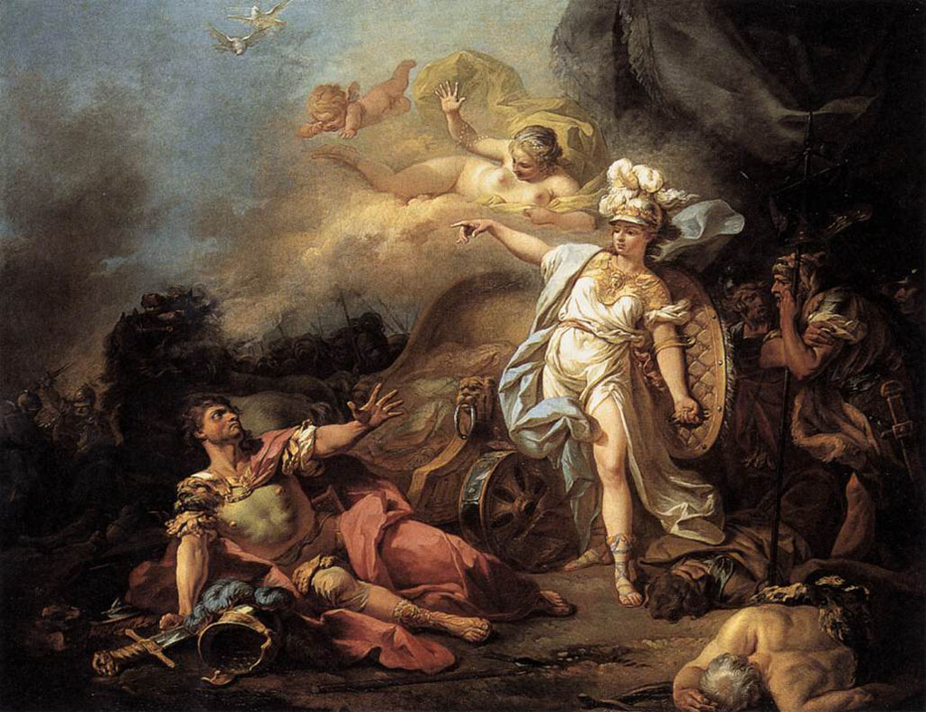
Pict. 1
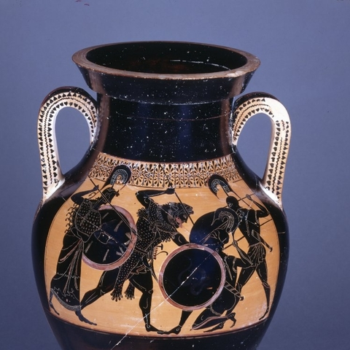
Pict. 2

