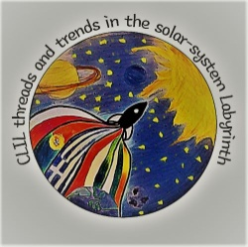
ANSWER KEY
A. Jupiter’s moons – Factfile
Students (Ss) need to study the a) the picture provided within the Factfile and look for key words in the text within the picture as well as look for one or two key words that they can extract or guess from the imagery, b) the text under the picture to add or confirm information. The data provided in the Factfile, both in the picture and in the text could be developed in a writing activity.
Key within the Factfile text : a) Io , Europa ,Ganymede and Io are called Galilean moons, because they were first discovered by the Italian astronomer, Galileo Galilei, b) in 1610.
B. VIDEO WATCHING
NOTE: It is recommended that the following video-watching, multiple-choice activity could be done before presenting the Factfile in Part A.
https://www.youtube.com/watch?time_continue=5&v=8sOFuNbdeWM&feature=emb_logo
Answer Key
1) a 2) b 3) b 4) a 5) b 6) a
The activity above is a video watching activity, not a listening activity. The Ss need to watch the video, pay attention to the multimodal elements (movement, text , colour ) and then decide on the answers.

Optional: Ss can watch https://www.youtube.com/watch?v=YZcVaJo_tLU and select some more data about Jupiter’s moons, which they could organize in a chart
C. Galilean moons
In this activity Ss need to present Jupiter’s moons, starting from the largest one (Ganymede) and finishing with the smallest (Europa). This could be both a writing activity and a speaking activity (or a combination of the two). This activity could be supported by images of the moons or Ss’ own creations of the moons.
D. Listening activity
This is a listening/gap-filling activity. Ss watch https://www.youtube.com/watch?v=oHpxCGeXU3c , a BBC documentary about Io, one of Jupiter’s moons, and fill in the gaps of the sentences with one proper word. These words are the key words which refer to Io’s qualities. The part of the video that is required for this activity is from 0:42 – 2:45
Answer Key
1) volcanic 2) surface - active 3) lakes – lava 4) 200 - diameter 5) million – lava - lake 6) surface - waves - rock 7) vision 8) moon’s 9) energy - heat 10) gravity - orbits - tops - clouds

E. Listening activity
This is a listening/matching activity. Ss watch https://www.youtube.com/watch?v=M8lUgmV6Bhg (0:17 – 2:56), and then match the qualities to the moons (Ganymede, Callisto, Io , Europa).
Answer Key
1) Io, 2) Io 3) Europa 4) Europa 5) Europa 6) Ganymede 7) Callisto 8) Callisto

F. Creative-writing activity
Ss will need a black marker or a pencil.
Ss study the text or the teacher reads it aloud. Then the Ss are given some time to select few words from the text, only those ones which they will use to produce a slogan or a motto. They blackout the rest of the text. In the end their text should look like that : 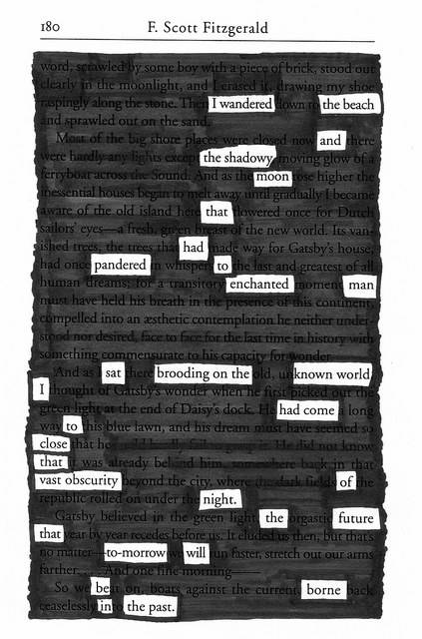
(source : https://www.anythinklibraries.org/events/blackout-poetry)
The purpose of this activity here is for the students to produce their motto about modern Europe.

