1. Can you recognize, name and order the planets of the solar system in the right sequence according to the distance from the Sun?

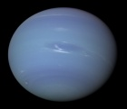 | 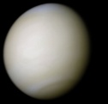 | 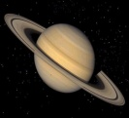 | 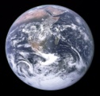 | 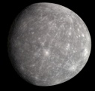 | 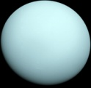 | 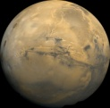 | 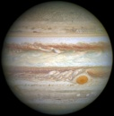
................ ................ ................ .............. ................ ................ .............. .............

2. Compare the planets above with the model of the solar system. What have you noticed?

3. Can you explain:

THE INNER PLANETS THE OUTER PLANETS SOLID SURFACE NO SOLID SURFACE

TERRESTIAL PLANETS GAS PLANETS

4. One of the giants is Jupiter. Watch the SS’ presentation about Jupiter. Find out why it is called the planet of the records? Use the words below in the correct form and write them down in the chart below.

big heavy thick stormy wide high volcanically active large strong protective

TEN JUPITER’S RECORDS

1. ...............................................................  2. ..............................................................  3. ..............................................................  4. ..............................................................  5. .............................................................. | 6. ..................................................................  7. .................................................................  8. ................................................................  9. ................................................................  10. .............................................................

5. Look at the chart (app. 1) providing information about the planets of the solar system. Can you answer the questions:

a) What is 1 AU?

b) What is a diameter?

c) Why are the planets’ masses written in roots?

d) Why don’t Mercury and Venus have any moons?

6. SPEAKING ACTIVITY:

a) Look at the chart again. In your groups, take turns and each of you chooses two sticks from the cup. The sticks have names of the planets written on them. Compare the two planets you have chosen. You have to say at least 3 sentences! Then the next person of the group continues the activity ...

b) While comparing the planets, use the words below in the correct form:

close / far big / small heavy / light long / short many / little

c) What differences did you notice about the inner and outer planets of the solar system?

